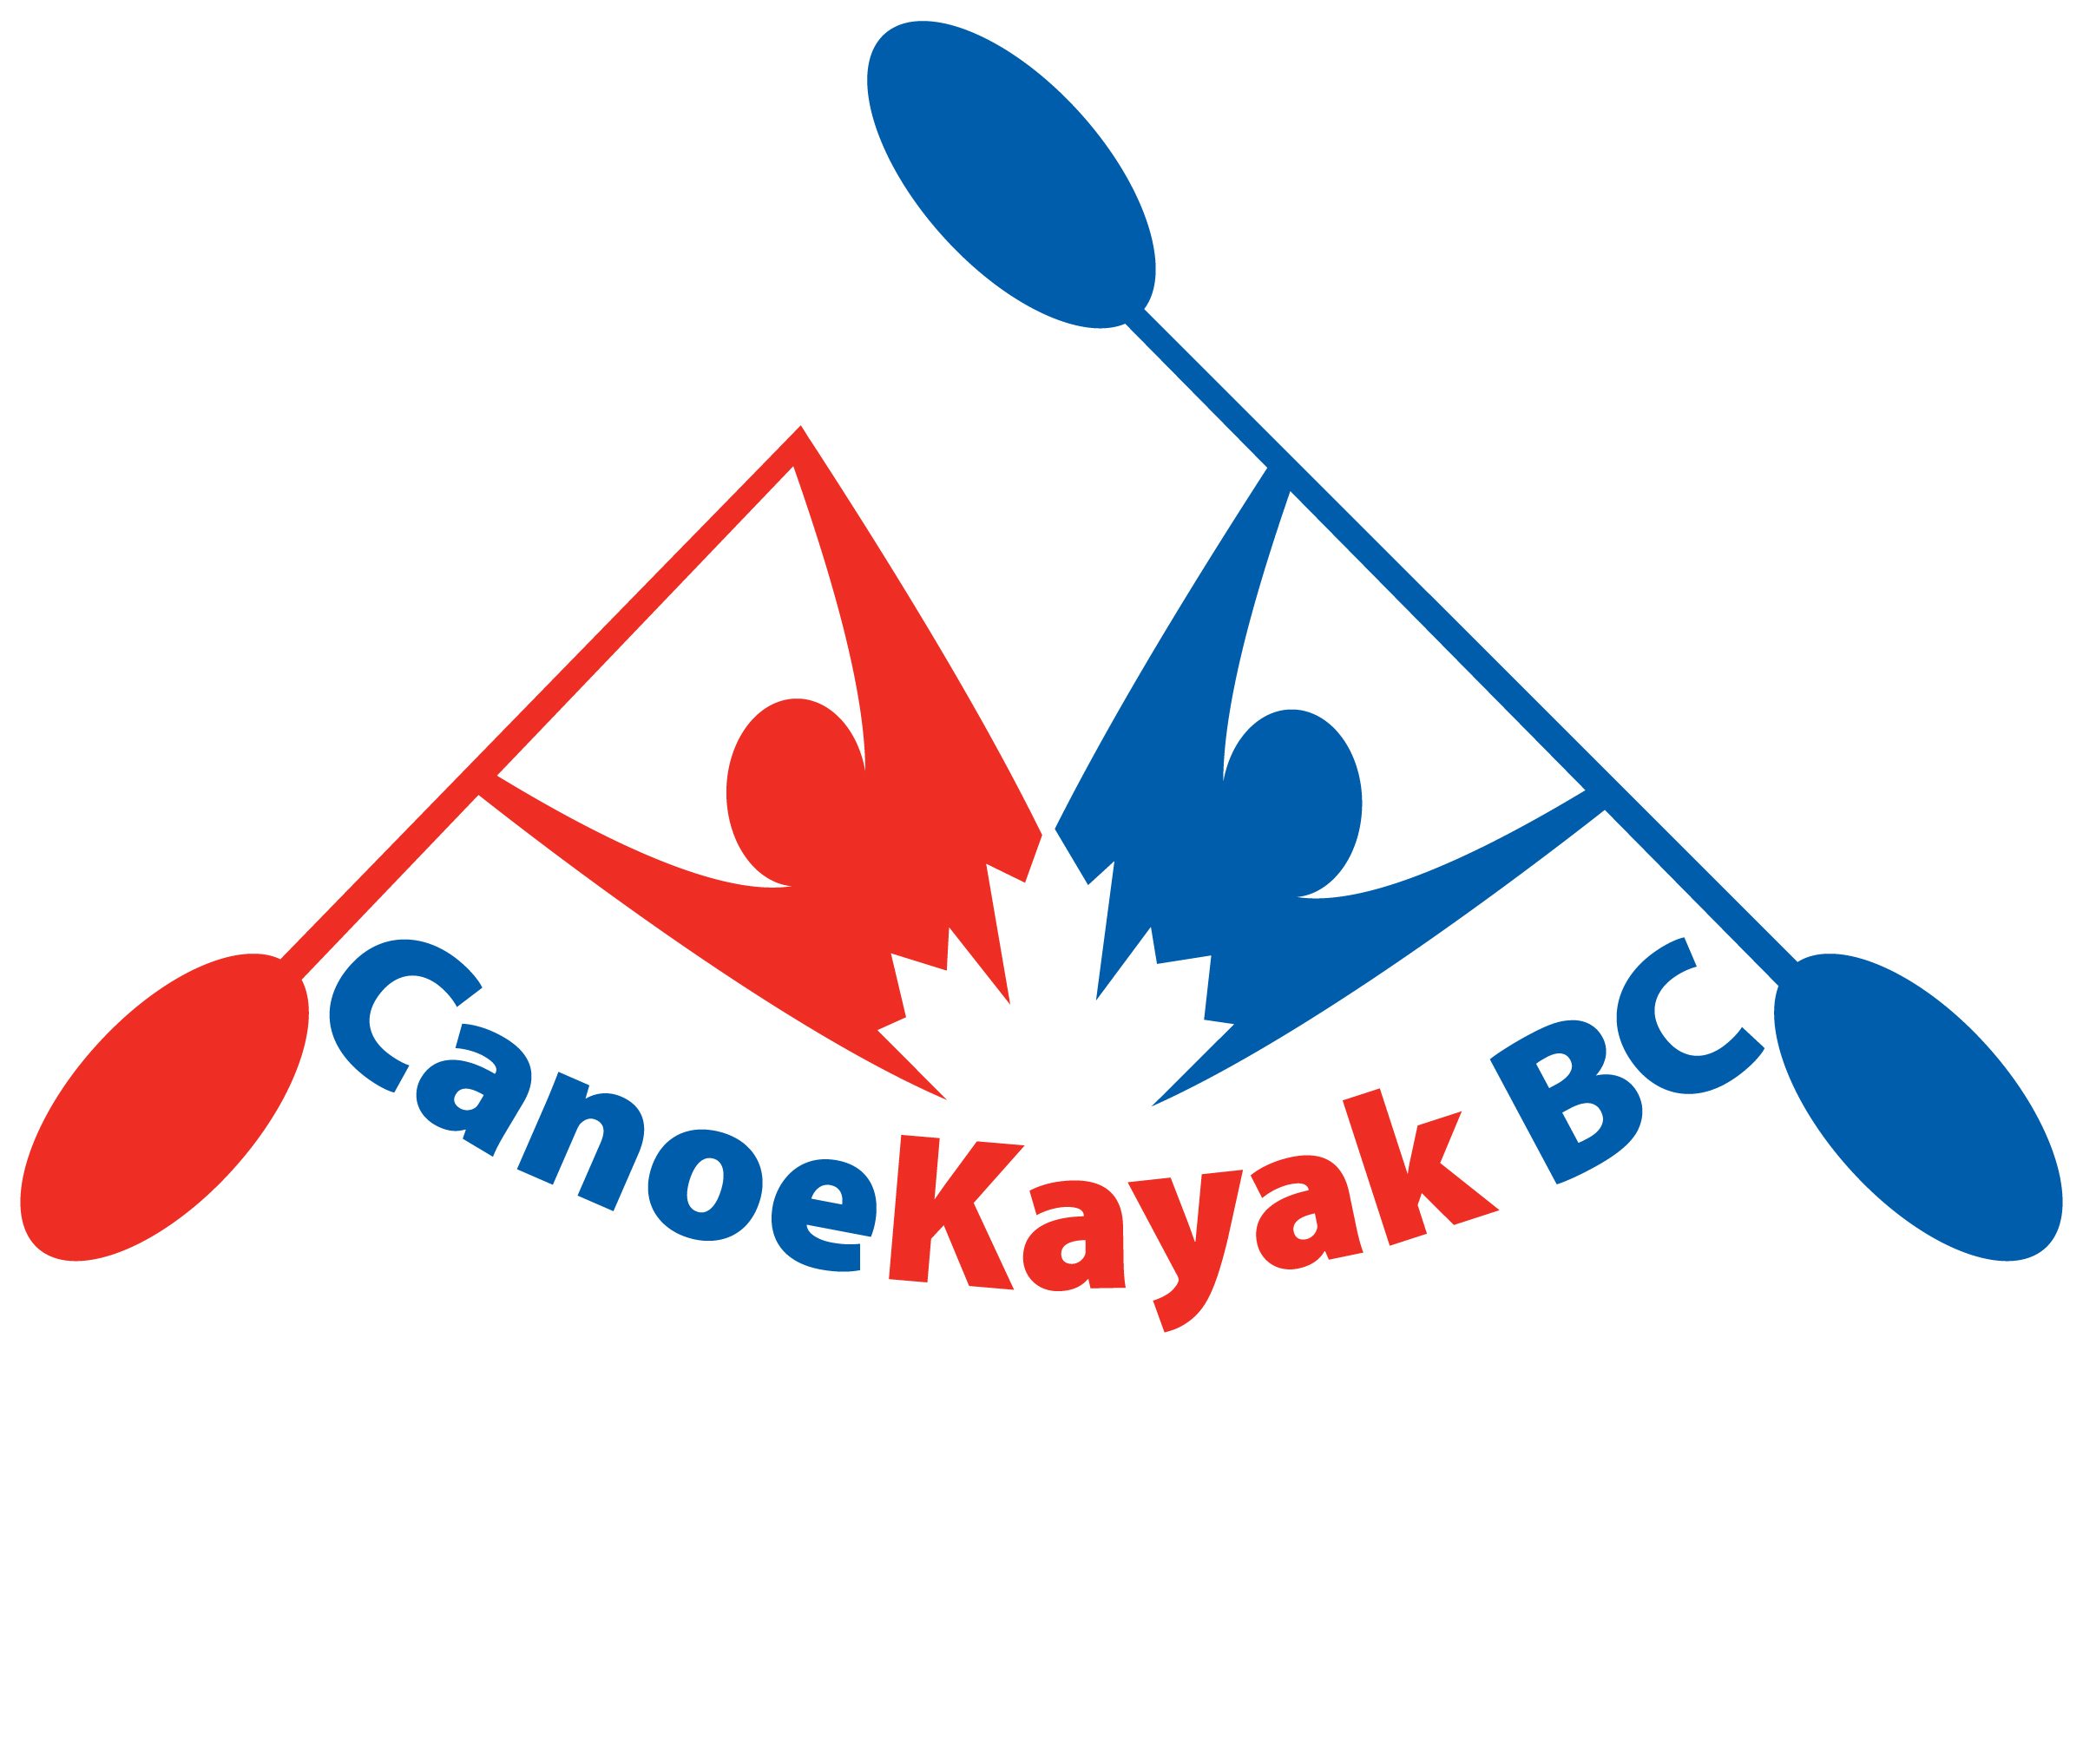
2016 CKBC AGM Agenda
Sunday April 23rd, 2017
Fortius Athlete Development Centre
Vancouver A Meeting Room
1:00 pm

- Call to Order

- Approval of the Agenda

- Approval of the Minutes of the previous AGM – May 7th, 2016

- Receiving of the Annual Reports – previously circulated

- Welcoming of new clubs in 2016-17 season

- False Creek Sprint Canoe Club
- Fort Canoe and Kayak Club
- Pitt Meadows Dyke Utilization Enhancement Society dba Alouette Paddling Club
- Revelstoke Paddling Association
- Flatwater Paddling Yukon

- Review of proposed governance changes

- Financial

- Election of Officers
  - VP Finance
  - Performance Director
  - Member at Large
  - Athlete Representative – to be completed electronically as per bylaws

- Naming of the Auditor

- New Business

- Adjournment

