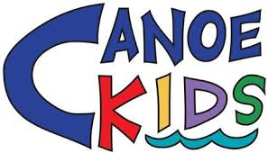
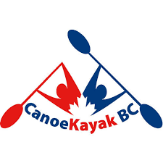
Additional Modules and Coach Training Opportunities:

Aboriginal Coaching Module:
The ACM is a professional development training tool for Aboriginal and non-Aboriginal coaches who coach Aboriginal athletes. The material in the ACM has been developed to meet the following learning objectives:
-Understanding the role of sport in Aboriginal communities;
-Understanding and positively influencing the community in which you coach;
-Coaching the whole person; coaching beyond the physical to include the mental (intellectual and emotional), spiritual and cultural;
-Responding to racism in sport;
-Establishing a code of behaviour for your team that respects differences and addresses racism;
-Helping those you coach make healthy lifestyle choices.
The course consists of three modules:
Module 1
Holistic Approach to Coaching encompasses a holistic approach to coaching which includes topics such as creating a positive environment, the Medicine Wheel, a coaching perspective: physical, mental, emotional, intellectual, cultural, and spiritual aspects, values (the Four Pillars), coach-to-community relationships.
Module 2
Dealing with Racism in Sport encompasses issues on dealing with racism in sport including definitions that may be useful in the discussion of racism and knowing when to use the right word to describe what is happening in a certain situation, i.e. discrimination, racism, prejudice, stereotype, systemic discrimination. It also discusses how to respond to racism and the three choices of response, examples of coaches’ responses, organizational responses to racism, creating a positive environment, and coach-to-family relationships.
Module 3
Individual and Community Health and Wellness encompasses topics on lifestyle, health, and nutrition, and how to be familiar with the unique lifestyle, health situations, and challenges that Aboriginal youth may face. Topics in this chapter include: understanding the community where you coach, mental health, personal and community health practices, diet and nutrition, health conditions and diseases, and influencing change.
Canucks Autism Network Workshop:
This workshop has two portions. In the morning is a classroom session at Fortius and the afternoon is a try-it format at Burnaby Lake. The try-it session is where you practice the skills that you have learned in the workshop with participants with autism.
The course will be credited as an NCCP professional development credit in your locker transcript.

- Workshop Topics will Include:
Autism 101: Challenges faced by individuals with autism in sports and recreation settings
- Communication Tips
- Teaching/Coaching Tools
- Motivation and Behaviour Support Strategies
- Tips for Successful Inclusion

