Nationals Qualifier – July 30th, 2011
Club: |  | Coach: |  |  | Contact info:
Please submit all entries to mj@canoekayak.ca | 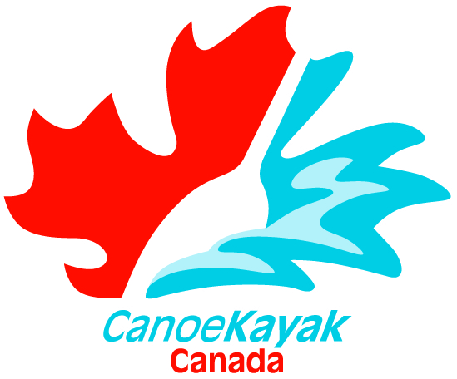  Athletes Name | Age Group | M/F | Planning to attend Nationals? | Club racing with at Nationals? | 6000m |  | 200 m | 500m | 1000m
1
2
3
4
5
6
7
8
9
10
11
12
13
14
15
16
17
18
19

