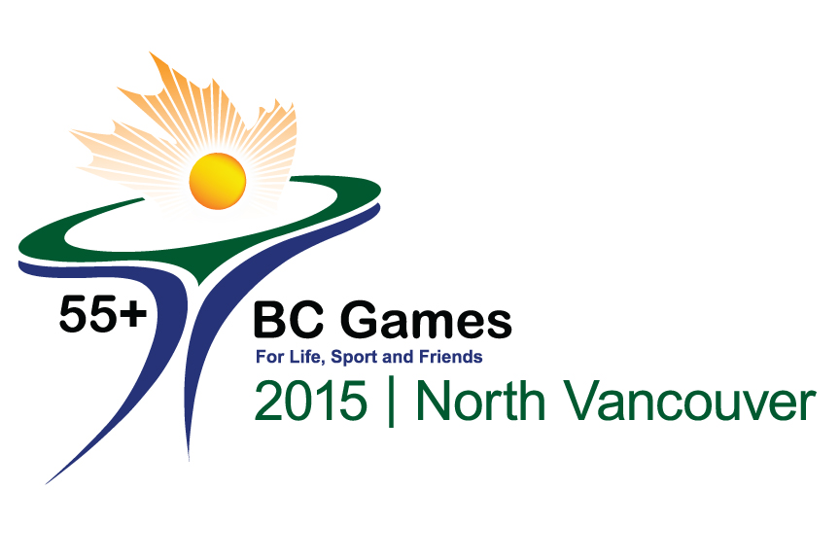
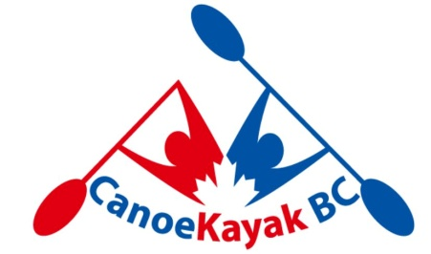
Dragon Boat Event Welcome Letter
August 11th, 2015
Hello Paddlers:
Welcome to the BC 55+ Games Dragon Boat event. We have a record 24 teams entered (11 women’s teams and 13 mixed teams) from almost every zone so we’re looking forward to some great racing.
TEAM BIO:
A request was recently sent asking each team to provide a BIO that we can use during the announcing of the event. Thank you to those of you who have sent some great information. A reminder to the rest of you to please send your short paragraph as soon as possible.
VENUE:
The event will be held on Burnaby Lake (6871 Roberts Street), which is the home of numerous rowing clubs, and the Burnaby Canoe and Kayak Club. As such there is a very well marked course that you can look forward to racing on.
PARKING:
There will be LIMITED onsite parking so participants are encouraged to carpool to the event or from the assigned remote parking area. Limited wheelchair accessible spots will be available on the outside edge of the athlete’s area and will only be available to those with a parking permit.
Those of you staying at the Fortius Athlete Development Centre are encouraged to leave your cars there. There is a path behind the overflow parking that will take you to the lake in less than 15 minutes.
TENTS/ATHLETE’S AREA:
Please bring your own tents, lawn chairs and tables. Spaces equivalent to 2 parking stalls in width will be assigned on a first come basis beginning at 1:30 on Wednesday August 26th. The centre aisle of the parking lot must be kept clear for emergency vehicles. There will be limited security so please do not bring valuables. Bins will be available for each team to use during races for your valuables and accreditation.
EQUIPMENT:
All boats with be BUK’s. No heads or tails will be used. Approved paddles and PFDs are available for both practice and race times to those crews who do not have their own equipment. Both must be returned immediately following your race.

FOOD:
Lunches are not provided by the BC Seniors Games however a food truck will be available onsite with healthy food choices….and coffee ! Water will be available. PLEASE BRING A REUSEABLE WATER BOTTLE. For those requiring a morning jump start there is a STARBUCKS in the Fortius Athlete Development Centre on the way at 3713 Kensington Avenue.
PRACTICE SCHEDULE:
Those wishing practice times are asked to communicate your request to mj@canoekayakbc.ca to schedule. Practice times are available from 1:00 until 5:30 on Wednesday August 26th. Participants will be asked to follow the lake traffic pattern during this time as other user groups will also be using the lake.
RACES:
Thursday August 27th
- 8:30 am - Team Leaders/Steersperson meeting – Burnaby Lake Pavilion
- 9:30 am – Round 1 – Random Qualifying Round (advance to Round 2 based on times)
- 11:00 am – Round 2 – Heats (advance to Round 3 Repechage based on placings)
- 12:40 pm – LUNCH
- 1:30 pm – Repechage
- 3:15 pm – Zone Reps Meeting – Rules Meeting

Friday August 28th
- 8:30 am – Team Leaders/Steersperson meeting – under the white marquis
- 9:30 am – Semi Finals (advance to final based on placings)
- 11:10 am – LUNCH
- 12:15 pm – Finals
- 2:30 pm – Medal Presentation

The racecourse will be 500m. The schedule is attached and the advancements documented within it. Our intent is to deliver the event on schedule.

VIEWING:
We will have access to the onsite pavilion for viewing on Thursday only.
We are looking forward to hosting you and wish all teams a memorable racing experience.

Race Management
CanoeKayak BC
604-465-5268
www.canoekayakbc.ca
mj@canoekayakbc.ca

Sport Chair
Dave Nosella
dave@nosella.net

Assistant Sport Chair
Mary Jane Abbott
mjabbott@telus.net
778-384-0584

