PMPC Eggatta - ICF Marathon Qualifier Entry Form
Club: |  | Coach: |  |  | Contact info:
Please submit all entries to info@pmpc.ca | 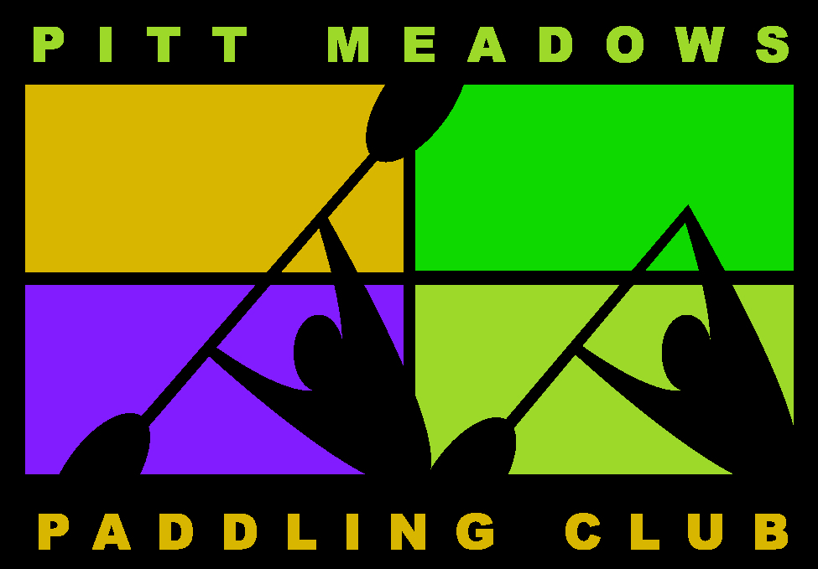  Athlete's Name | 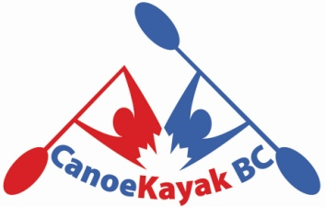  CKC Age Group | M/F | Train to Train Singles | U18, U23 and Open Women's Singles | Open Men's Singles |  | Train to Train Doubles | U18, U23 and Open Women's Doubles | Open Men's Doubles
1
2
3
4
5
6
7
8
9
10
11
12
13
14
15
16
17
18
19
20

