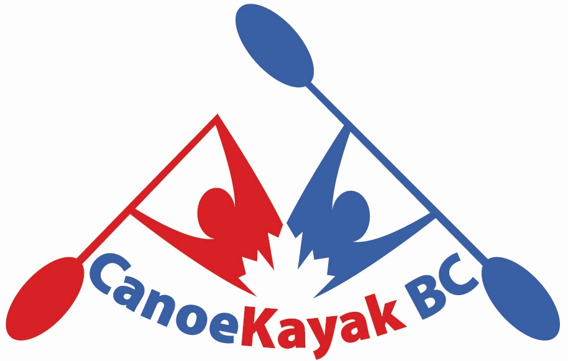

CKBC Girls Camp Checklist

- Camping chair
- Sleeping bag
- Pillow
- Air Mattress
- *Tents will be provided
- Eating utensils
- Plate/bowl
- Water bottle/Mug
- Watch(for training/alarm)
- Lots of clothes for all types of weather
  - Rain gear/cold weather gear/warm weather gear
- Running shoes/Sandals
- Bug Spray
- Bathing Suit
- Sunscreen
- Towel
- Flashlight/headlamp
- Money for cafe
- Money for drier- $2.50/cycle
- Money for shower- $1/5min
- Toiletries
- Snacks (granola bars, cookies etc.)
- Life Jacket
- Paddle
- Boat
  - There will be team boats available at Fort Langley Canoe Club but athletes should try and bring a single to paddle

