Holmes River EAP

There is limited cellular phone reception in the Holmes River Valley. Nearest reception begins near the highway 16 bridge, reception is patchy on the highway to west to McBride.
The Holmes River is mostly snow melt fed, during the festival it tends to be at medium to high levels. The run is class III with a waterfall at the end. There are sections with multiple channels and lines through boulders, pour overs, holes and haystacks. Log jams are present in the smaller side channels and at the up stream end of islands. There are several sweepers along the banks. Eddies are fairly frequent although corner eddies can be powerful. There are 5 major rapids.
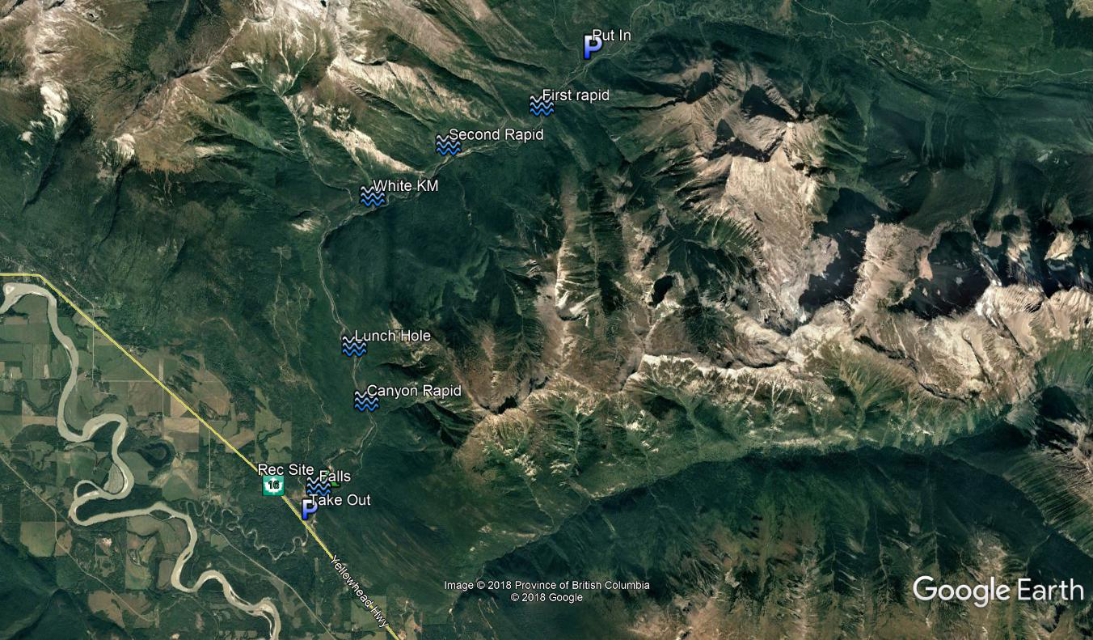
Put in is located at 53°20'41.41"N 119°55'56.74"W
Take out 53°15'4.98"N 120° 1'43.54"W
The Holmes FSR runs next to the river and the majority of the run is visible from the road.
Prior to setting out on the river: review river signals, identify river buddies, ensure personal and rescue gear is in order, and discus potential river hazards

Emergency Response Plan
- Ensure Personal Safety prior to and during rescue
- Identify the number of involved individuals
- Ensure there are no other individuals in danger
- Group paddlers, identify rolls and execute rescue
- Provide First Aid as needed
  - Assess Consciousness
  - Airway
  - Breathing
  - Circulation
  - Trauma
- Contact Emergency Services if required (9-1-1)
  - Nearest Medical care
    - McBride Hospital & Health Centre - Hospital
1136 5 Ave, McBride, BC (11.6 km from takeout)
    - Jasper Healthcare
518 Robson Street, Jasper AB (155 km from takeout)
    - University Hospital of Northern BC
1474 Edmonton Street, Prince George, BC (221km from takeout)
- Prepare for transportation if required

