Lower Dore River EAP

There is limited cellular phone reception in the Dore River Valley. Nearest consistent reception is near the highway 16 bridge, although there may be patchy reception from the highway to the start of the Dore FSR.
The Dore River is glacier fed, during the festival it tends to be at medium levels (0.8m – 1.2m on the BC water tool online Gauge). Levels can fluctuate throughout the day and small changes in flow can make for significant changes in the character of the river and the crux rapid. The run is continuous class III with multiple lines through boulders, pour overs, holes and haystacks. Log jams are present in the smaller side channels and at the up stream end of islands. There are several sweepers along the banks. Infrequent eddies can hold 1 or 2 boats. The crux of the run is down stream of the bridge. It is typically run from right to left, cutting below mid channel rocks to avoid the large corner boil/eddy on river left and the exiting the corner below the hole on river right into large mid channel haystacks.
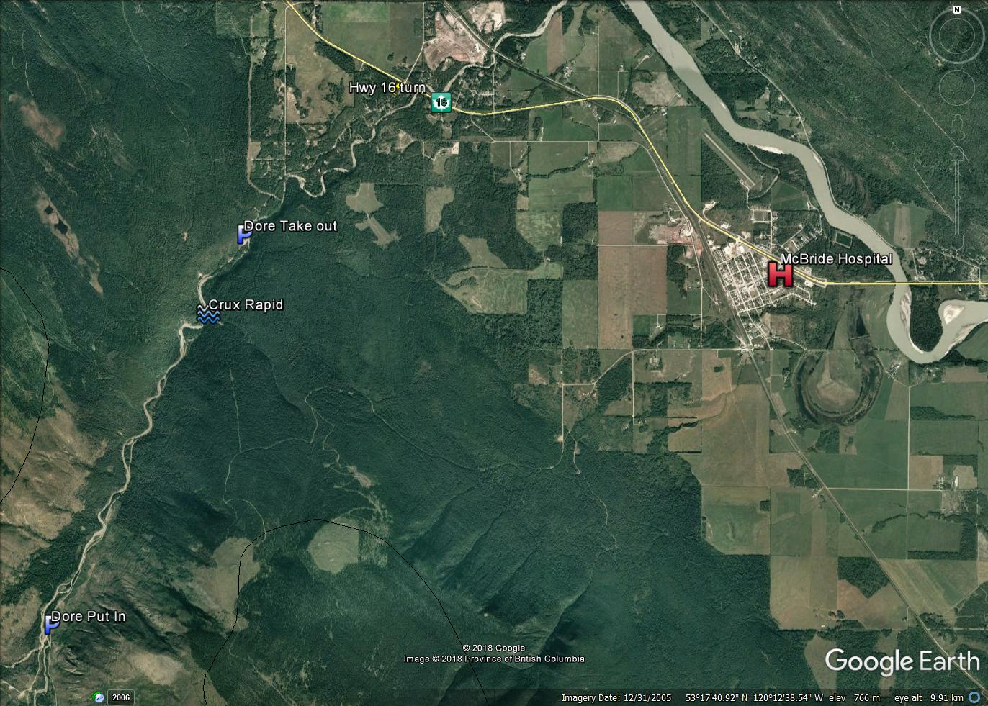

Put in is located at 53°15'55.03"N 120°17'18.93"W
Take Out 53°18'22.97"N 120°15'12.86"W (alternate takeout at HWY 16 53°19'18.03"N 120°13'25.56"W)
The Dore FSR runs next to the river and the majority of the run is visible from the road.
Prior to setting out on the river: review river signals, identify river buddies, ensure personal and rescue gear is in order, and discus potential river hazards

Emergency Response Plan
- Ensure Personal Safety prior to and during rescue
- Identify the number of involved individuals
- Ensure there are no other individuals in danger
- Group paddlers, identify rolls and execute rescue
- Provide First Aid as needed
  - Assess Consciousness
  - Airway
  - Breathing
  - Circulation
  - Trauma
- Contact Emergency Services if required (9-1-1)
  - Nearest Medical care
    - McBride Hospital & Health Centre - Hospital
1136 5 Ave, McBride, BC (8.7 km from takeout)
    - Jasper Healthcare
518 Robson Street, Jasper AB (174 km from takeout)
    - University Hospital of Northern BC
1474 Edmonton Street, Prince George, BC (206km from takeout)
- Prepare for transportation if required

